Tycoon game recipe

Contents

Create hierarchy of folders 1

Make owner 1

Droppers 5

Customize the color and material of parts that are dropping 8

Make Buttons for purchasing Dropper, Colorizer etc. 12

Make the Cash Collector 16

# Create hierarchy of folders

1. Create the hierarchy of folder, model and folders within the model as shown below.
2. A screenshot of a computer

   Description automatically generated
3. Note, MoneyValue is IntValue, DropColorValue is BrickColorValue, MaterialValue is StringValue, OwnerValue is ObjectValue , TycoonColor is BrickColorValue

# Make owner

1. Create a part->block. Pos = (-5, 0.25, -45) size=(70, 0.5, 50). Rename to Floor. Drag drop to MainItems. Give desired color and material. Anchor it.
2. Create a part->block, size=(10,12,2), anchored, transparency = 0.2, cancollide off. Rename to Door. Pos = (-5, 6.55, -69). Material asphalt. Color cement color. Ctrl+g to group as model, rename to OwnerDoor and drag drop it to MainItems.
3. Add below code to Core in Scripts.

local tycoon = script.Parent.Parent

local mainItems = tycoon:FindFirstChild("MainItems")

local values = tycoon:FindFirstChild("Values")

mainItems.OwnerDoor.Door.Touched:Connect(function(hit)

if values.OwnerValue.Value == nil then

local player = game.Players:GetPlayerFromCharacter(hit.Parent)

if player then

if player:FindFirstChild("HasTycoon").Value == false then

values.OwnerValue.Value = player

end

end

end

end)

1. Add script in ServerScriptService and rename to ‘leaderstats’. Add below code.

game.Players.PlayerAdded:Connect(function(player)

local leaderstats = Instance.new("Folder",player)

leaderstats.Name = "leaderstats"

local hasTycoon = Instance.new("BoolValue", player)

hasTycoon.Name = "HasTycoon"

hasTycoon.Value = false

end)

1. Play and see. When you walk through the door, OwnerValue’s value must show player’s name.
2. 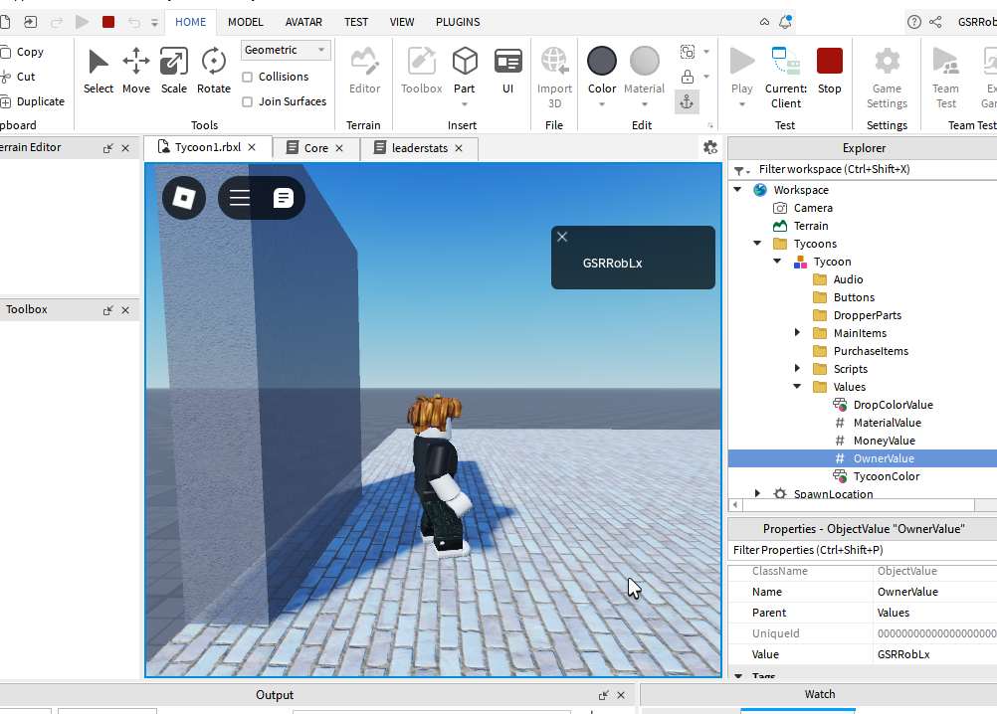
3. Duplicate the Door, move it up, and scale it down to 1/10th in height, make transparency 0 and rename it to DoorTop. To DoorTop add a ‘SurfaceGui’ and to that add a TextLabel. See below.
4. 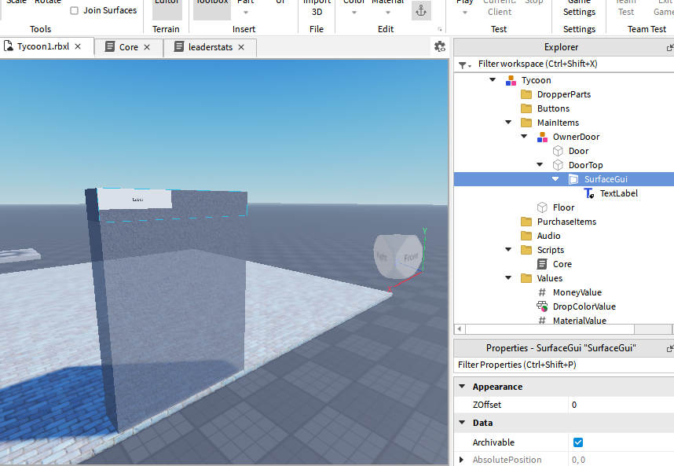
5. For TextLabel set background transparency to 1, size to (1,0,1,0), so that it takes up entire space. Check TextScaled. Font, Color to desired. To TextLabel add a UIStroke.
6. Add below line in Core script, after - .
7. mainItems.OwnerDoor.DoorTop.SurfaceGui.TextLabel.Text = tostring(values.OwnerValue.Value).."'s Tycoon"
8. Play and see – when we walk through door we must see ‘user name’s tycoon’
9. A screenshot of a computer

   Description automatically generated

# Droppers

1. Add part->block size=( 41, 0.3, 5), pos = (-14, 0.6, -28). Anchor it. Add a script and rename to ‘ConveyorScript’. In that add below code.
2. script.Parent.Velocity = Vector3.new(15,0,0)
3. Play and see. When gamer goes on the part, he must move on the conveyor.
4. Rename part to ConveyorBelt and move it to MainItems.
5. To create the dropper – add 3 parts – rename to part1, part2, part3. Anchor all 3. Set color to whitish, materials to ‘Ceramic tiles’. Set part1 size=(3,6,2) pos = (-32, 3, -32). Set part2 size = (1.5, 1, 4) and pos = (-32, 6, -29.5). Set part3 size = (1.5, 1, 2) and pos = (-32, 4.6, -28).
6. Rename part3 to Spawner. Group part1 and part2 to folder, rename to DropperFolder. Group DropperFolder and Spawner to Model, rename to Dropper. Set Spawner’s transparency to 1 and it’s cancollide to unchecked.
7. Create part->block. Size = (1,1,1). Add a BillboardGui to this part, to it add a frame. Set BillboardGui’s size to (5,0,5,0), MaxDistance to 40. Set frame’s size to (1,0,0.2,0), background transparency to 1. Add TextLabel to this frame, set it’s backTransperency to 1 and size to (1,0,1,0), enable TextScaled. Font and color to desired. To TextLabel add UIStroke and thickness to 3. Change TextLabel text to ‘$5 Cash’. Text color could be green.
8. Drag drop BillboardGUI into ReplicatedStorage. See below. Can delete temporary part of size (1,1,1).
9. A screenshot of a computer

   Description automatically generated
10. Add a script to Dropper model and rename to DropperScript. In the script add code below.

local tycoon = script.Parent.Parent.Parent

local dropPartsFolder = tycoon:FindFirstChild("DropperParts")

local dropColVal = tycoon:FindFirstChild("Values").DropColorValue

local matVal = tycoon:FindFirstChild("Values").MaterialValue

local bbGui = game.ReplicatedStorage:FindFirstChild("BillboardGui")

while wait(3) do

local clGui = bbGui:Clone()

local part = Instance.new("Part", dropPartsFolder)

part.Size = Vector3.new(1,1,1)

part.BrickColor = dropColVal.Value

part.Material = Enum.Material[matVal.Value]

part.Name = "DropperPart"

part.CFrame = script.Parent.Spawner.CFrame

local cashVal = Instance.new("IntValue", part)

cashVal.Value = 5

cashVal.Name = "CashValue"

clGui.Parent = part

clGui.Frame.TextLabel.Text = "$"..cashVal.Value.." Cash"

game.Debris:AddItem(part, 15)

end

1. Drag drop Dropper model to PurchaseItems. Ensure that MaterialValue has Value set to Plastic.
2. Play and see. We must see parts getting cloned and dropping on Conveyor and moving to the end with UI of cash value attached to it.
3. A screenshot of a video game

   Description automatically generated

# Customize the color and material of parts that are dropping

1. See the image below. We will build a ‘structure’ with color buttons using many part->block.
2. Create part->block size=(1,10,12) pos=( -39, 5.4, -42) and CastShadow uncheck. Anchor it. Rename it to ‘Back’.
3. Duplicate above part, size = (1.3, 1.5, 10.6), pos =( -39, 9.5, -42), rename to ‘Bar’.
4. Duplicate above part, size=( 0.5, 1.5, 1.5), pos =( -38.5, 7.3, -38). Rename to ‘Button’. Color to red. Add a ClickDetector.
5. 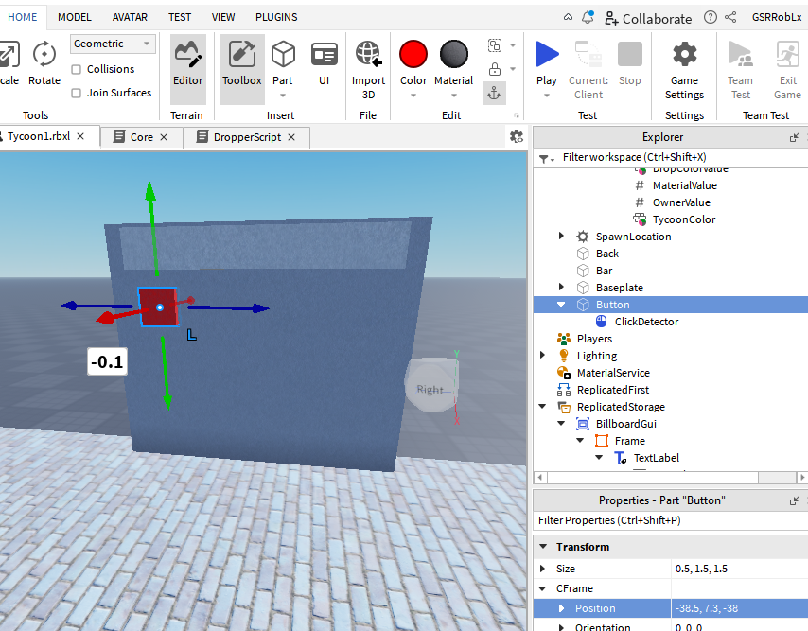
6. Now duplicate this button to 14 other buttons with different colors. As shown below.
7. 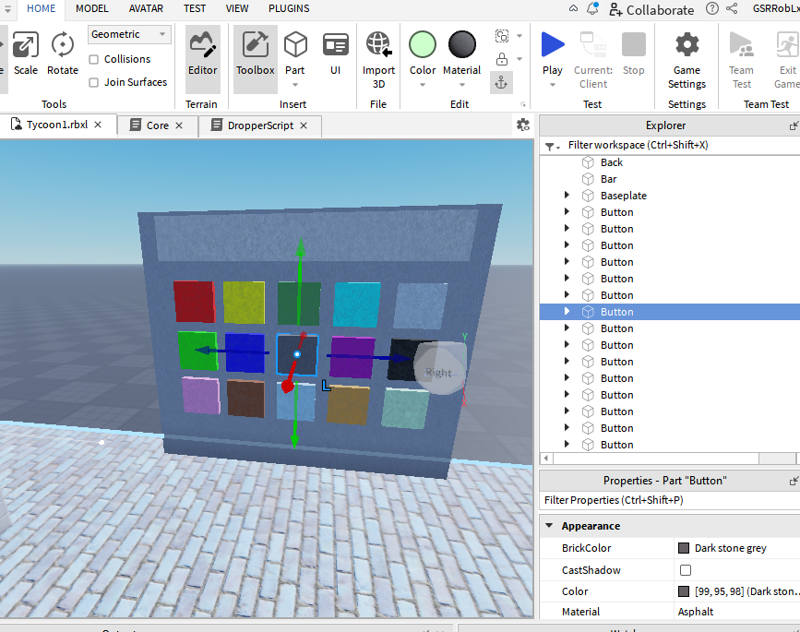
8. Select all buttons and group as folder and rename folder to Buttons. Select Back, Bar and Buttons folder and group as Model and rename to Colorizer. Move Colorizer to PurchaseItems.
9. Add a script to colorizer. Add the code below to script.

local buttons = script.Parent:FindFirstChild("Buttons")

local bar = script.Parent:FindFirstChild("Bar")

local values = script.Parent.Parent.Parent.Values

for i,v in pairs(buttons:GetChildren()) do

v.ClickDetector.MouseClick:Connect(function()

values.DropColorValue.Value = v.BrickColor

bar.BrickColor = v.BrickColor

end)

end

1. Play and see. When we press the color button, the next part spawned and the bar color will be of that color.
2. A screenshot of a computer

   Description automatically generated
3. Duplicate the ‘Colorizer’ and rename to ‘Materializer’. Now in Materializer make color of all buttons same. Just pick different material for each of the button.
4. In the script make the below change.
5. In Materializer script

values.MaterialValue.Value = v.Material.Value

bar.Material = v.Material

1. In DroopperScript
2. Replace part.Material = Enum.Material[matVal.Value] with part.Material = matVal.Value
3. Play and see. Now we must be able to configure both color and material of the product spawned from the dropper.
4. At end of conveyor, add a square part same width as conveyor, same height. Set material and color to ‘yellow’ Neon. Reduce color to reduce glow if needed. Anchor it.
5. In leaderstats script add below code.

local cash = Instance.new("IntValue", leaderstats)

cash.Name = "Cash"

cash.Value = 0

1. Rename the yellow part to ‘CashPart’. Move it under MainItems->ConveyorBelt. Add a script under CashPart and in the script add code below.

local values = script.Parent.Parent.Parent.Parent.Values

script.Parent.Touched:Connect(function(hit)

if hit.Name == "DropperPart" and hit:IsA("BasePart") then

values.MoneyValue.Value += hit:FindFirstChild("CashValue").Value

hit:Destroy()

end

end)

1. Play and see. Note that part moves down conveyor and disappears as soon as it hits the yellow part. While game running see the value of MoneyValue and see it increase by 5 every time the product reaches end of conveyor belt.
2. 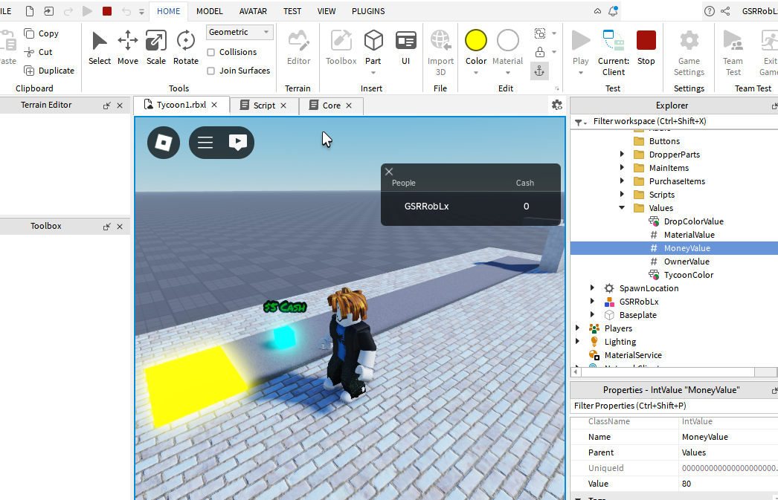

# Make Buttons for purchasing Dropper, Colorizer etc.

1. Insert part->cylinder size=( 0.1, 2, 2) and pos = (24, 0.6, -65), or = (0, 90, 90). Ensure it is anchored. Rename to ‘Button’. Select it Ctrl+g to group as model. Rename model to DropperButton. To dropperbutton, add a ‘intValue’, rename to Price and ‘stringValue’ rename to Object. Set Value of Price to 0. Add billboardgui to Button. Set maxdistance to 40, uncheck resetOnSpawn, size to (5,0,5,0). To billboardgui add a Frame, set it’s size to (1,0,0.5,0), backgroundtransperency to 1.To it add a TextLabel and size to (1,0,0.4,0), backgroundtransperency to 1, texscaled to checked, font and color to desired. Add UIStroke to TextLabel, thickness to 3. Change text to ‘Dropper1 - $0’.
2. Dragdrop DropperButton to Tycoon->Buttons. Set DropperButton->Object’s Value to ‘Dropper’ the same name in ‘PurchaseItems’.
3. Duplicate DropperButton and rename to ‘ColorizerButton’. To this add a ‘stringValue’ rename to Dependency and it’s Value to Dropper. And set ColorizerButton->Object->Value to Colorizer.
4. In the Core script change the code as below.

local tycoon = script.Parent.Parent

local mainItems = tycoon:FindFirstChild("MainItems")

local values = tycoon:FindFirstChild("Values")

local buttons = tycoon:FindFirstChild("Buttons")

local purItms = tycoon:FindFirstChild("PurchaseItems")

local objs = {}

mainItems.OwnerDoor.Door.Touched:Connect(function(hit)

if values.OwnerValue.Value == nil then

local player = game.Players:GetPlayerFromCharacter(hit.Parent)

if player then

if player:FindFirstChild("HasTycoon").Value == false then

values.OwnerValue.Value = player

mainItems.OwnerDoor.DoorTop.SurfaceGui.TextLabel.Text = tostring(values.OwnerValue.Value).."'s Tycoon"

end

end

end

end)

if buttons then

for i,v in pairs(buttons:GetChildren()) do

spawn(function()

if v:FindFirstChild("Button") then

print("Button found")

print(v.Object.Value)

local newObj = purItms:FindFirstChild(v.Object.Value)

if newObj ~= nil then

print("new obj is not nil")

objs[newObj.Name] = newObj:Clone()

newObj:Destroy()

else

v:Destroy()

end

if v:FindFirstChild("Dependency") then

print("Dependency found")

v.Button.Transparency = 1

v.Button.BillboardGui.Frame.Visible = false

v.Button.CanCollide = false

coroutine.resume(coroutine.create( function()

if purItms:WaitForChild(v.Dependency.Value) then

v.Button.Transparency = 0

v.Button.BillboardGui.Frame.Visible = true

v.Button.CanCollide = true

end

end ))

end

v.Button.Touched:Connect(function(hit)

local player = game.Players:GetPlayerFromCharacter(hit.Parent)

if player then

if values.OwnerValue.Value == player then

if v.Button.CanCollide == true then

if player:FindFirstChild("leaderstats").Cash.Value >= v.Price.Value then

player.leaderstats.Cash.Value -= v.Price.Value

objs[v.Object.Value].Parent = purItms

v:Destroy()

end

end

end

end

end)

end

end)

end

end

1. Play and see, walk through the door, then when we step on dropper button, dropper will appear and colorizer button will appear. When step on colorizer button, the colorizer will appear.
2. Now to change the color of button, if the user has enough money to buy the part. Add a script to Button and copy the code below

local ownerValue = script.Parent.Parent.Parent.Parent.Values.OwnerValue

local bbTex = script.Parent.BillboardGui.Frame.TextLabel

local price = script.Parent.Parent.Price.Value

bbTex.Text = "Dropper1 - $"..tostring(price)

ownerValue.Changed:Connect(function()

if ownerValue.Value then

local player = ownerValue.Value

while wait(0.25) do

if player:FindFirstChild("leaderstats").Cash.Value >= price then

script.Parent.BrickColor = BrickColor.new("Lime green")

else

script.Parent.BrickColor = BrickColor.new("Really red")

end

end

end

end)

1. Add same script to Button of Colorizer also. Change ColorizerButton->Price->Value to 5
2. Play and see. Walk through the Tycoon door. Dropper button will be green, when we step on it, dropper and colorizer button will appear (colorizer button will be red because it costs 5$)
3. Now Duplicate ColorizerButton and rename to MaterializerButton. Change Object->Value to Materializer. Update the Button->Script, bbText.Text.
4. Play and see. When we step on dropper both colorizer and materializer buttons will appear along with dropper, but in red.
5. Just set the ServerScriptService->leaderstats, cash.Value to 10, save, and play and see. Now we must be able to step on 2 green buttons to purchase colorizer and materializer.

# Make the Cash Collector

1. Add a part->block, anchor it. Size = (4, 0.2, 7), pos = (24, 0.6, -52). Material asphalt, cement color. Rename to Base.
2. Duplicate Base. Rename to Button. Size= (2.5, 0.2, 4.2), pos = (23.95, 0.8, -52.1). Material to plastic color to green.
3. Add part->Wedge, anchor it. Material to asphalt, color to cement. Size=(5.7, 2, 0.6), pos=( 25.7, 1.7, -51.95). Rename to DisplayBase. Add part->block, Green, plastic, anchored. Rename to Display, size =( 1.7, 0.1, 4.6), pos = (25.713, 1.766, -52), or=( 0, 0, 71.839).
4. To Display add a surfacegui, to this add TextLabesl with size (1,0,1,0) ( we will need to adjust the face, Setting to Top works). Rotate the Display so that label shows correctly.
5. Select Button, Base, DisplayBase and Display and group to model, rename to CashCollector.
6. A screenshot of a computer

   Description automatically generated
7. Make the TextLabel backgroundtransperency to 1, textscaled to checked, color and font to desired. Set text to ‘$ 0’.
8. Drag drop CashCollector into main items.
9. Update the Core script as below –

local tycoon = script.Parent.Parent

local mainItems = tycoon:FindFirstChild("MainItems")

local values = tycoon:FindFirstChild("Values")

local buttons = tycoon:FindFirstChild("Buttons")

local purItms = tycoon:FindFirstChild("PurchaseItems")

local objs = {}

local debounce = false

mainItems.OwnerDoor.Door.Touched:Connect(function(hit)

if values.OwnerValue.Value == nil then

local player = game.Players:GetPlayerFromCharacter(hit.Parent)

if player then

if player:FindFirstChild("HasTycoon").Value == false then

values.OwnerValue.Value = player

mainItems.OwnerDoor.DoorTop.SurfaceGui.TextLabel.Text = tostring(values.OwnerValue.Value).."'s Tycoon"

end

end

end

end)

if buttons then

for i,v in pairs(buttons:GetChildren()) do

spawn(function()

if v:FindFirstChild("Button") then

print("Button found")

print(v.Object.Value)

local newObj = purItms:FindFirstChild(v.Object.Value)

if newObj ~= nil then

print("new obj is not nil")

objs[newObj.Name] = newObj:Clone()

newObj:Destroy()

else

v:Destroy()

end

if v:FindFirstChild("Dependency") then

print("Dependency found")

v.Button.Transparency = 1

v.Button.BillboardGui.Frame.Visible = false

v.Button.CanCollide = false

coroutine.resume(coroutine.create( function()

if purItms:WaitForChild(v.Dependency.Value) then

v.Button.Transparency = 0

v.Button.BillboardGui.Frame.Visible = true

v.Button.CanCollide = true

end

end ))

end

v.Button.Touched:Connect(function(hit)

local player = game.Players:GetPlayerFromCharacter(hit.Parent)

if player then

if values.OwnerValue.Value == player then

if v.Button.CanCollide == true then

if player:FindFirstChild("leaderstats").Cash.Value >= v.Price.Value then

player.leaderstats.Cash.Value -= v.Price.Value

objs[v.Object.Value].Parent = purItms

v:Destroy()

end

end

end

end

end)

end

end)

end

end

mainItems.CashCollector.Button.Touched:Connect(function(hit)

local player = game.Players:GetPlayerFromCharacter(hit.Parent)

if player ~= nil then

if values.OwnerValue.Value == player then

if player.Character.Humanoid.Health > 0 then

if debounce == false then

debounce = true

mainItems.CashCollector.Button.BrickColor = BrickColor.new("Really blue")

player.leaderstats.Cash.Value = player.leaderstats.Cash.Value + values.MoneyValue.Value

values.MoneyValue.Value = 0

mainItems.CashCollector.Display.SurfaceGui.TextLabel.Text = "$"..tostring(player.leaderstats.Cash.Value)

wait(2)

debounce = false

mainItems.CashCollector.Button.BrickColor = BrickColor.new("Lime green")

end

end

end

end

end)

1. Play and see, now when we step on green button of cash collector, after the dropper starts spawning products and they get into yellow part of conveyor, user’s cash balance will be increased and shown in display.
2. 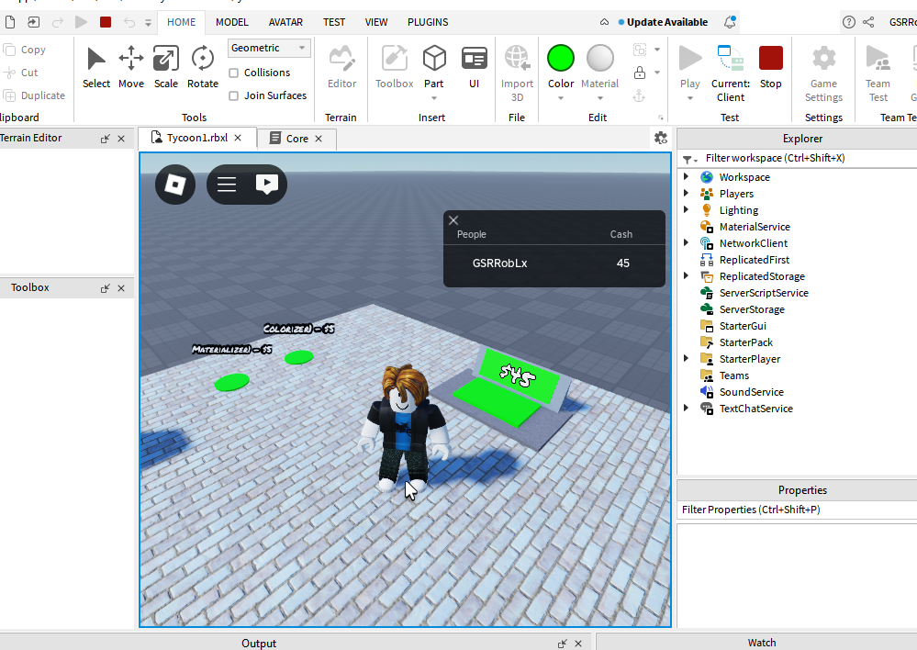
3. Enjoy!